***volatile*** keyword guarantees that the **value of the volatile variable** will **always be read from the main memory** and **not from Thread's local cache**.

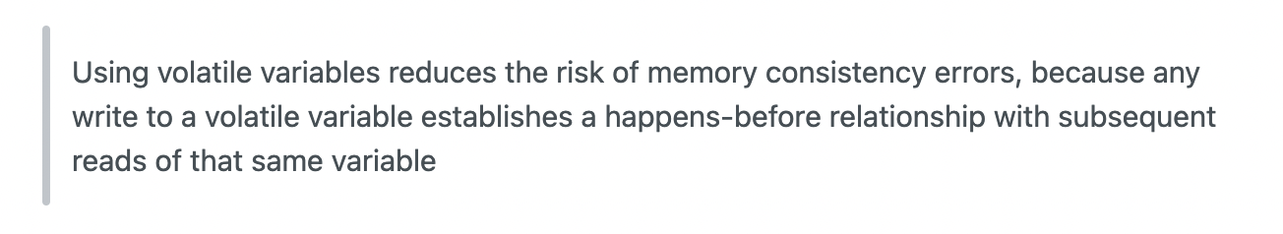

This means that **changes to a volatile variable are always visible to other threads**. It also means that **when a thread reads a volatile variable**, **it sees not just the latest change to the volatile**, **but also the side effects of the code that led up the change**.

